SSN COLLEGE OF ENGINEERING, KALAVAKKAM
DEPARTMENT OF COMPUTER SCIENCE & ENGINEERING
Internet Programming Lab – CS8661
Programming Assignment 8– HelloJSP using Apache Tomcat Server ________________________________________________________________________

Write index.jsp to display form with a submit button. Set the method attribute of the form to “get” to generate GET request to the server. Write a welcome.jsp which utilizes JSTL tag to display the welcome message when the button is clicked.

Follow the directory structure for creating HelloJSP Web application and follow the guidelines below to configure and deploy web application.

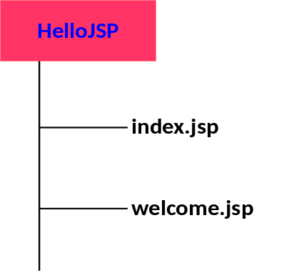

Create a Folder HelloJSP and keep index.jsp and welcome.jsp in that. Place the folder in webapps
Navigate to webapps→examples→WEB-INF→lib to get the files jstl.jar and standard.jar file
Create a folder tree WEB-INF→lib and place the files in HelloJSP

